All images are microsoft stock images unless stated below.

Resource name | Page number | Image | Credit
Session 1 - Roadmap to success | 12 |   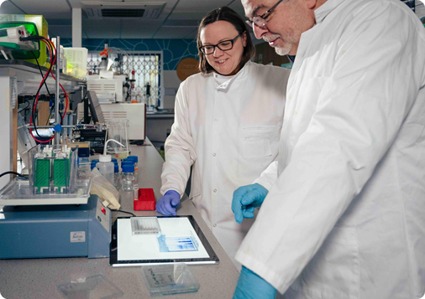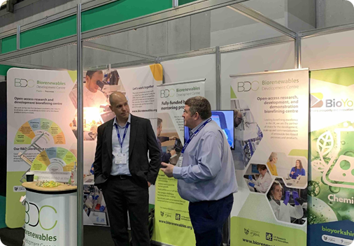 | Biorenewables Development Centre
Session 3 - Feedstocks and pre-treatment | 13 | 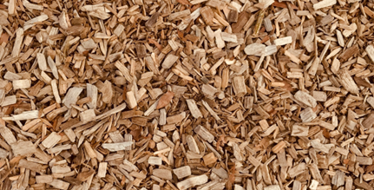  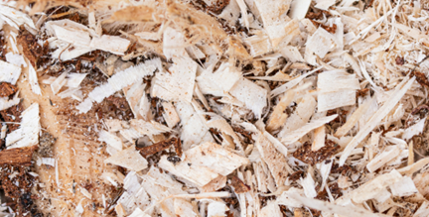  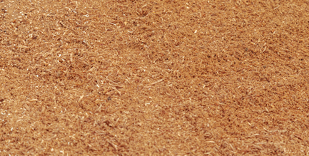 | Woodchip Photo by Rob Evel on Unsplash  Shavings Photo by Marek Studzinski on Unsplash  Sawdust Photo by Collab Media on Unsplash
Session 3 - Feedstocks and pre-treatment | 14 | 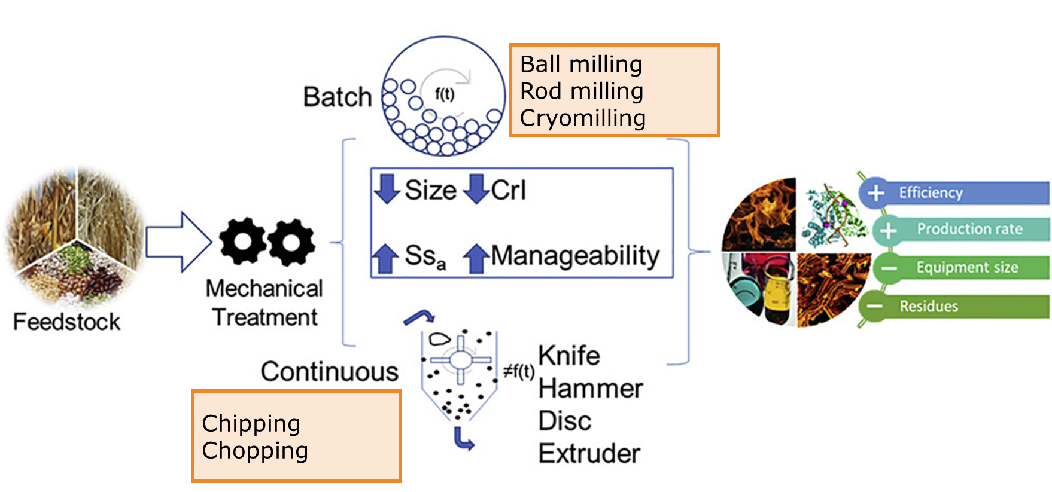 | Image from Mechanical pretreatment of lignocellulosic biomass toward enzymatic/fermentative valorization  https://www.sciencedirect.com/science/article/pii/S2589004222008823
Session 3 - Feedstocks and pre-treatment | 15 | 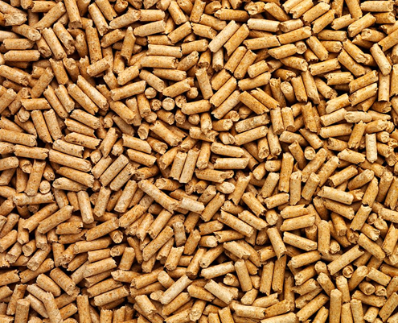  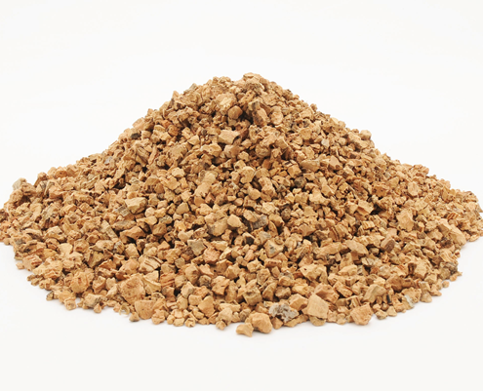 | Pellets, prills or crushed (for Ag Gyp): https://www.eco-gem.com/pellets-prills-crushed-differences-explained/
Session 3 - Feedstocks and pre-treatment | 16 | 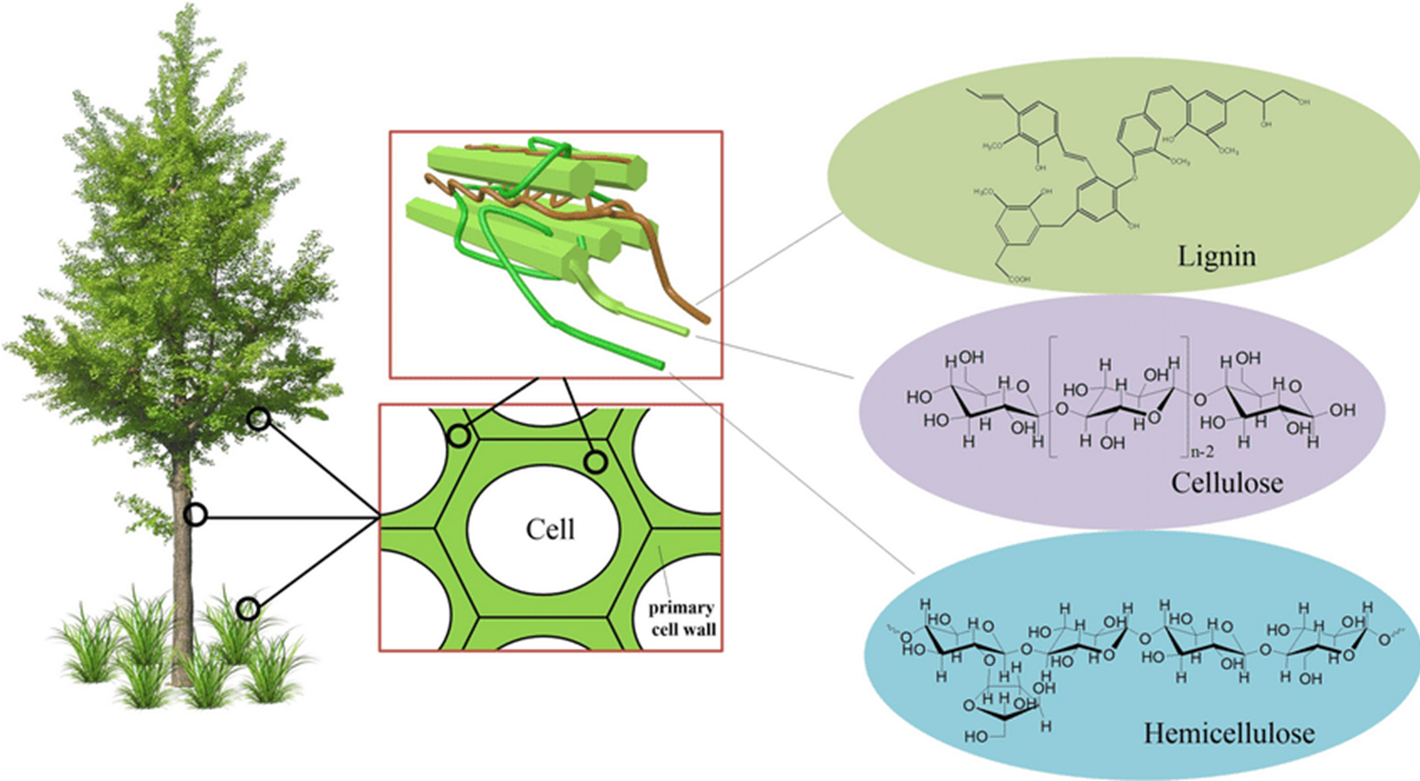 | Image from Heterogeneous strategies for selective conversion of lignocellulosic polysaccharides, DOI:10.1007/s10570-022-04434-8
Session 3 - Feedstocks and pre-treatment | 17 | 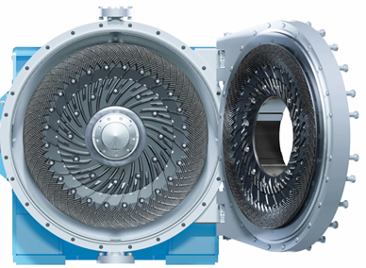 | Mechanical – pressurised disc refiner - image from Andritz: https://www.andritz.com/newsroom-en/panelboard/2024-03-22-lignatherm
Session 4 - Bioprocessing | 4 | 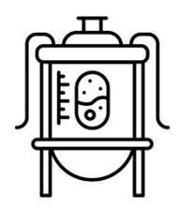 | iStock image - Stock illustration ID:2188346914  https://www.istockphoto.com/vector/bioreactor-black-line-icon-gm2188346914-606872988
 | 7 |  | Royalty free from Dreamstime https://www.dreamstime.com/bioreactor-color-line-icon-vector-isolated-element-editable-stroke-image364894144
 | 9 | 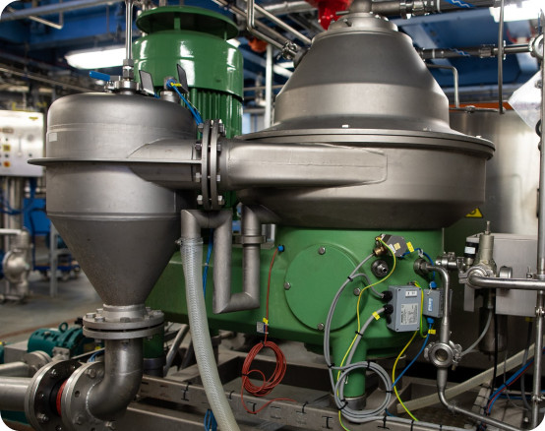  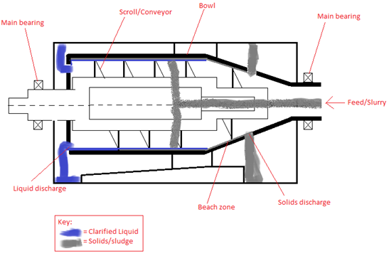  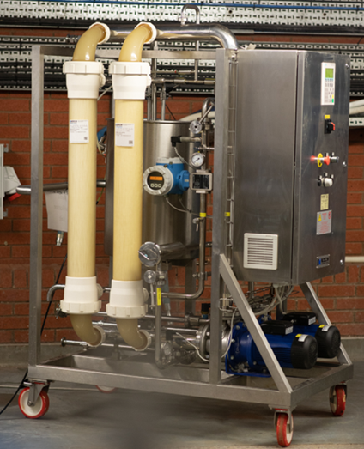 | CPI  Decanter centrifuge  https://commons.wikimedia.org/wiki/File:Horizontal_Decanter_Centrifuge.png  CPI
 | 10 | 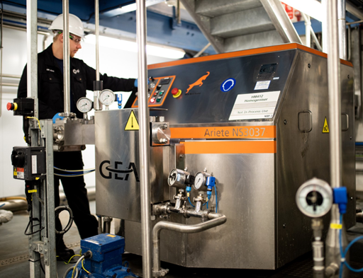 | CPI
Session 6 - Processing - Extraction, reaction and other | 5 | 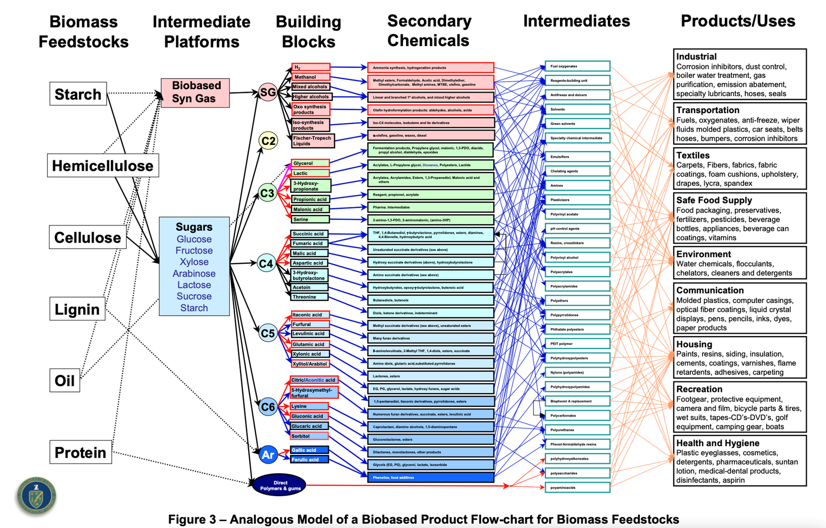 | Image source Top Value Added Chemicals from Biomass, Volume 1 – Results of Screening for Potential Candidates from Sugar and Synthesis Gas  http://www.eere.energy.gov
Session 6 - Processing - Extraction, reaction and other | 7 | 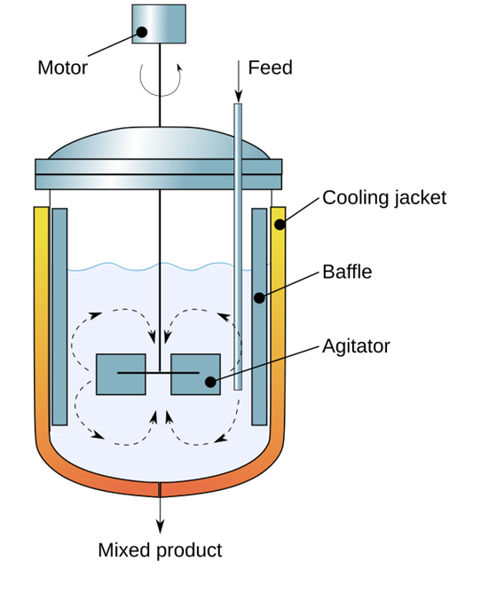 | https://erik-engheim.medium.com/what-is-a-chemical-reactor-c7e3857f7f99
Session 6 - Processing - Extraction, reaction and other | 10 | 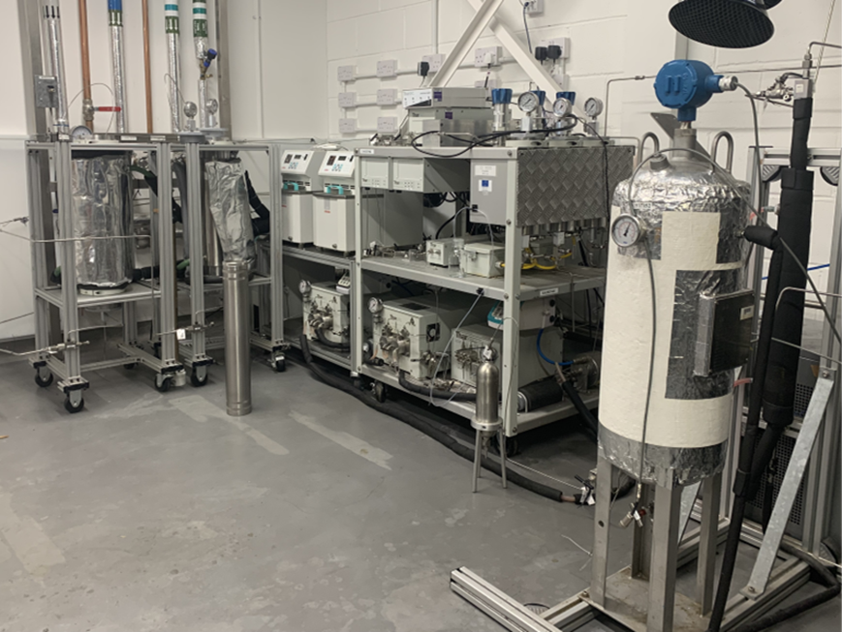 | Biorenewables Development Centre
Session 6 - Processing - Extraction, reaction and other | 11 | 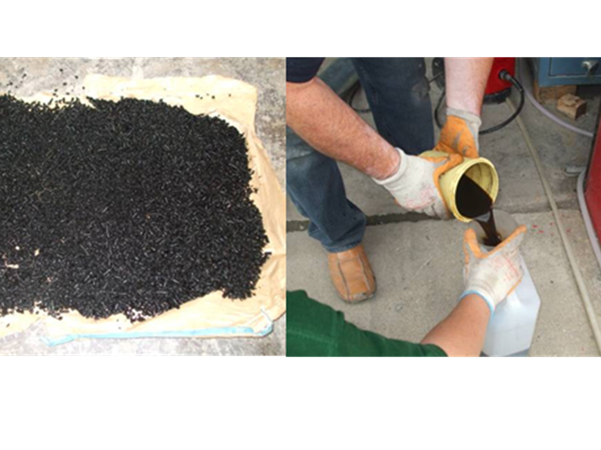 | University of York
Wrap up Day 1 | 8 | 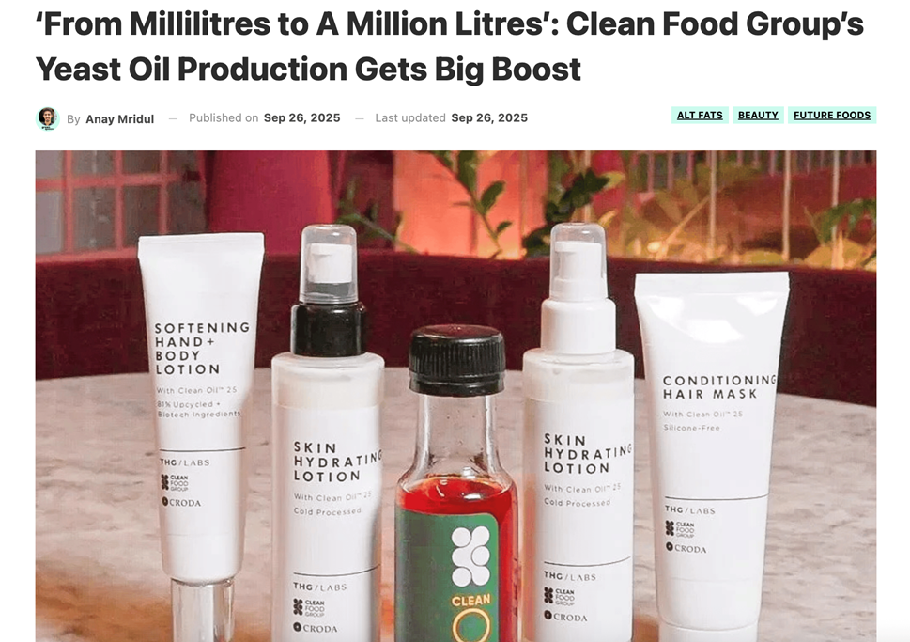 | https://www.greenqueen.com.hk/clean-food-group-yeast-oil-sustainable-fats-fermentation-facility/
Wrap up Day 1 | 9 | 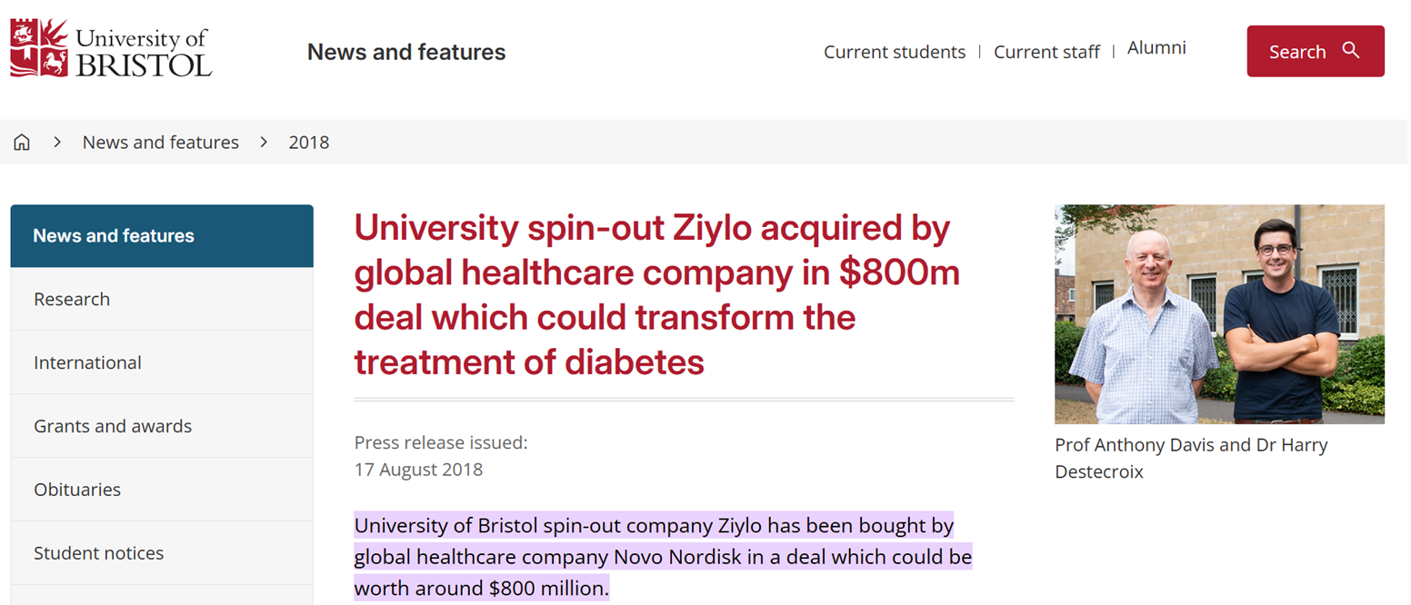 | https://www.bristol.ac.uk/news/2018/august/ziylo-deal.html
Wrap up Day 1 | 10 | 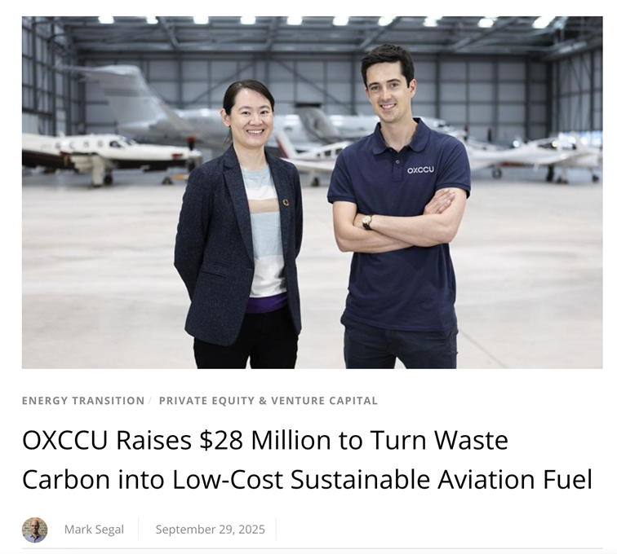 | https://www.esgtoday.com/oxccu-raises-28-million-to-turn-waste-carbon-into-low-cost-sustainable-aviation-fuel/
Session 9 - Downstream processing | 2 | 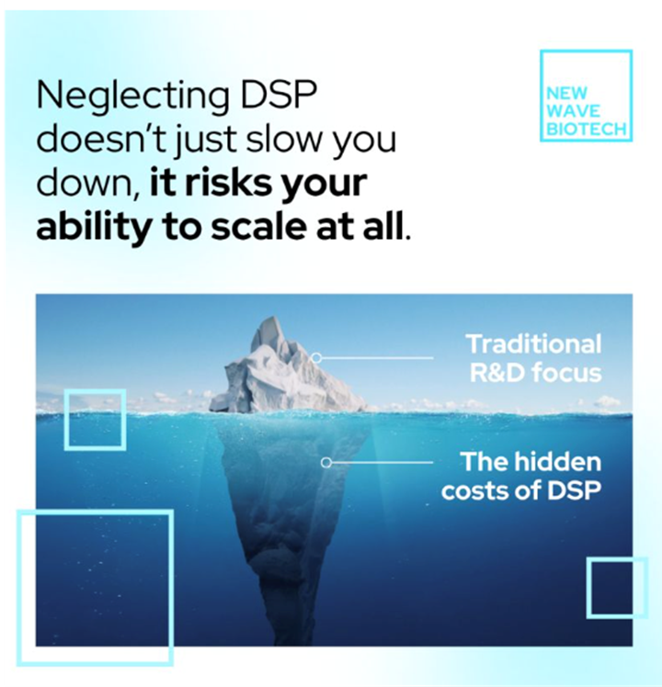 | New Wave Biotech
Session 9 - Downstream processing | 7 | 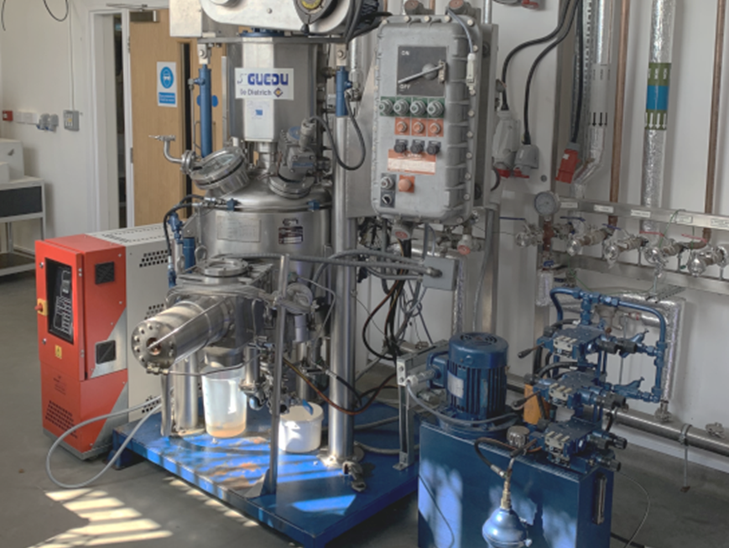 | Biorenewables Development Centre
Session 9 - Downstream processing | 7 | 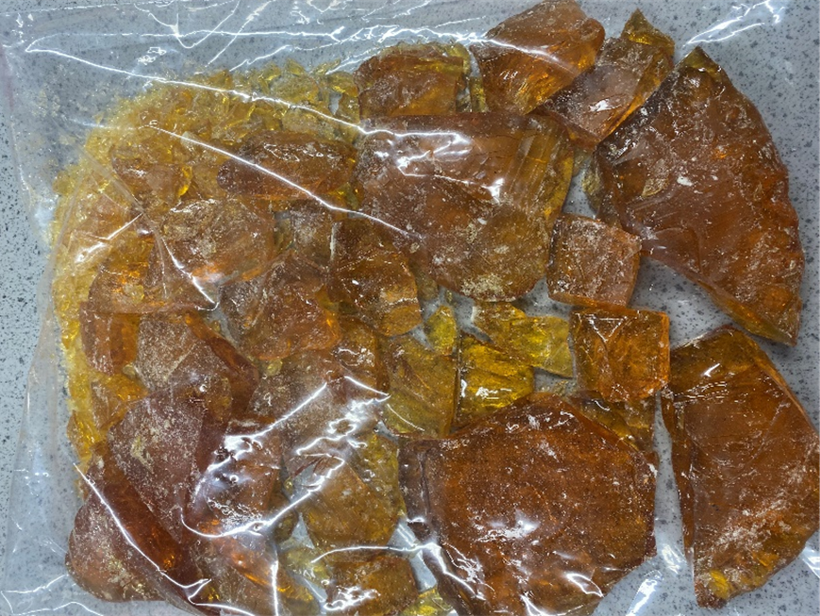 | Biorenewables Development Centre (section now removed)
Session 9 - Downstream processing | 9 | 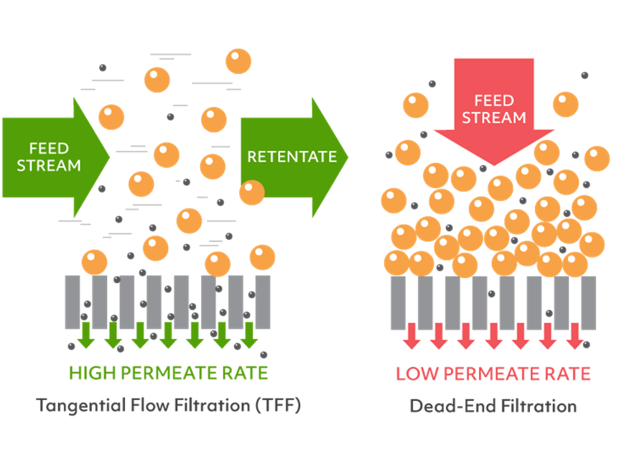 | https://formulatrix.com/pulse-tangential-flow-filtration/
Session 9 - Downstream processing | 10 | 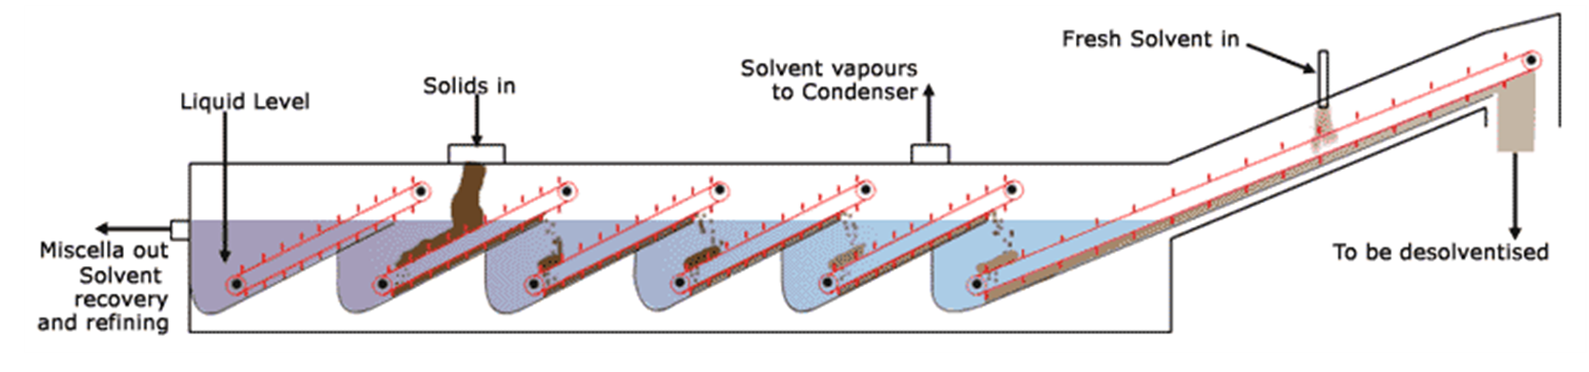 | http://www.crownironasia.com/Sections.asp?ID=47
Session 9 - Downstream processing | 11 | 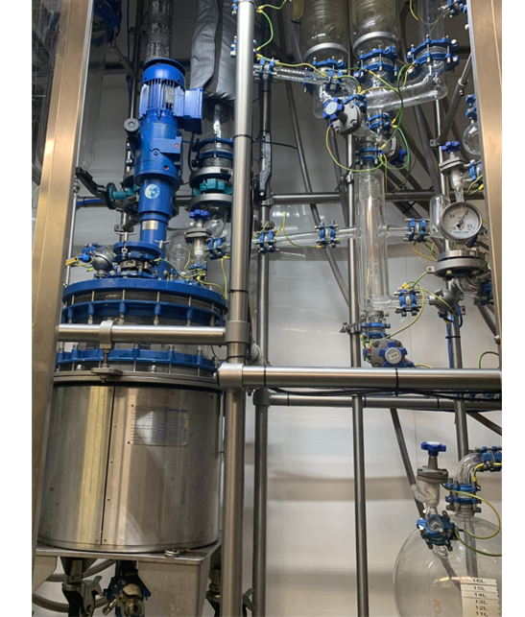 | Biorenewables Development Centre
Session 9 - Downstream processing | 12 | 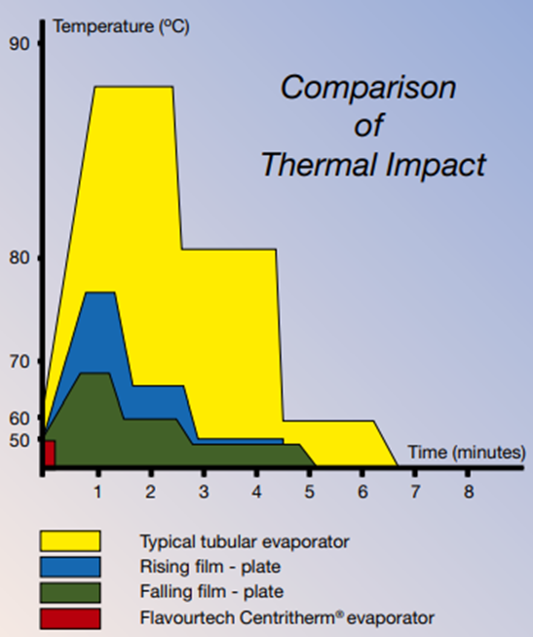 | Flavourtech PTY
Session 9 - Downstream processing | 13 | 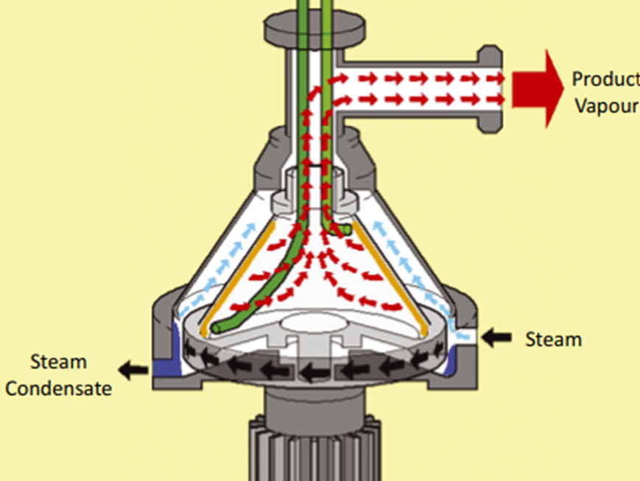 | Flavourtech PTY
Session 9 - Downstream processing | 14 | 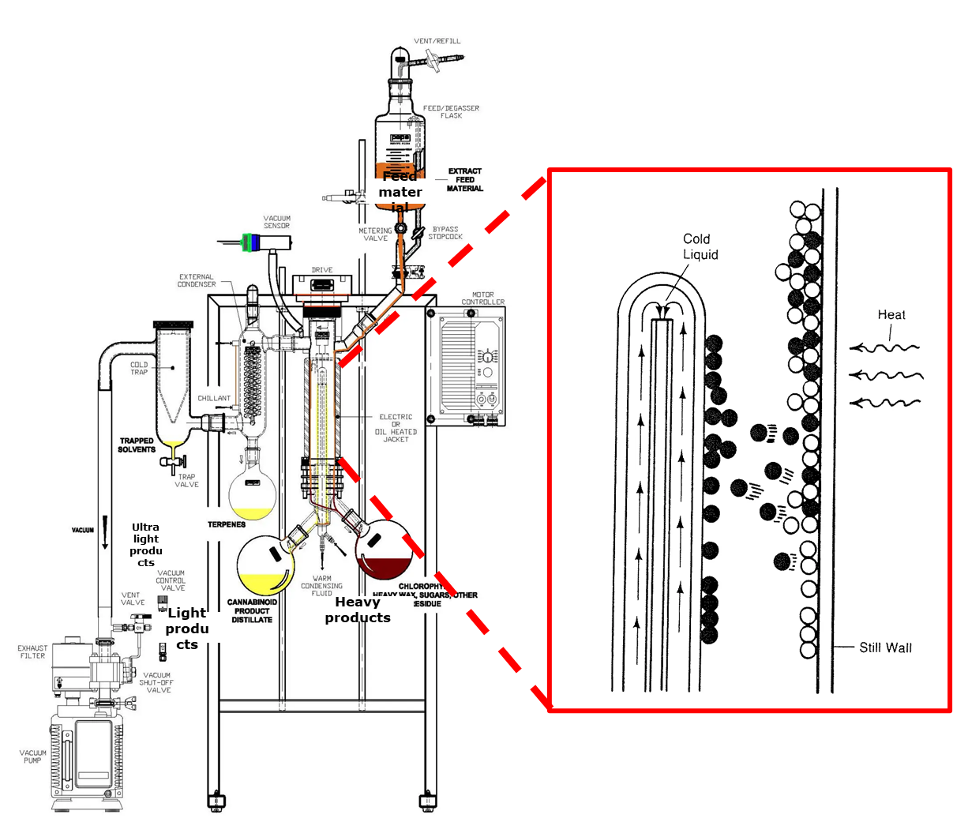 | Pope Scientific Inc
Session 9 - Downstream processing | 17 | 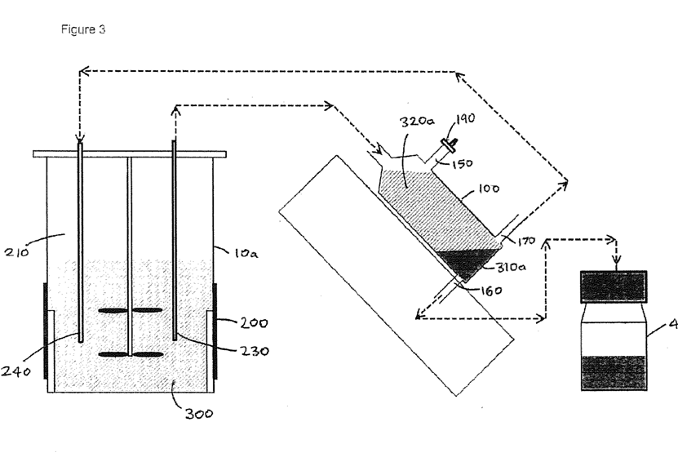 | Patent Winterburn & Dolman WO2017220957A1

